**Safe Lab Procedures and Tool Use**

**Objectives**

Upon completion of this chapter, you should be able to answer the following questions:

n

What are the safe working conditions and

procedures?

n

What tools and software are used with personal

computer components and what is their purpose?

n

What is proper tool use?

**Key Terms**

This chapter uses the following key

terms. You can find the definitions in the Glossary.

*electrostatic discharge (ESD)*

*page 55*

*antistatic wrist strap*

*page 55*

*page 56*

*current*

*page 56*

*power fluctuation*

*blackout*

*page*

*57*

*brownout*

*page 57*

*noise*

*page 57*

*spike*

*page 57*

*page 57*

*power surge*

*page 57*

*power protection device*

*page 57*

*surge suppressor*

*uninterruptible power supply (UPS)*

*page*

*57*

*line conditioner*

*page 57*

*page 57*

*standby power supply (SPS)*

*page 58*

*material safety data sheet (MSDS)*

*Occupational Safety and Health Administration*

*)*

*OSHA*

*(*

*page 59*

*Chemicals Hazard*

*Information and Packaging for*

*page 59*

*Supply Regulations 2002 (CHIP 3)*

*antistatic mat*

*page 59*

*hand tools*

*page 62*

*flat-head screwdriver*

*page 62*

*Phillips-head screwdriver*

*page 62*

*hex*

*page*

*driver*

*63*

*needle-nose pliers*

*page 63*

*tweezers*

*page 63*

*part retriever*

*page 63*

*cleaning tools*

*page 63*

*diagnostic tools*

*page 63*

*page 63*

*disk management tools*

*Format*

*page*

*64*

*page 64*

*Scandisk*

*Defrag*

*page 64*

*Disk Cleanup*

*page 64*

*Disk Management*

*page 64*

*workbench*

*page 70*

51

.qxp 8/20/10 1:36 PM Page

9781587132636_ch02

This chapter covers basic safety practices for the workplace, hardware and software tools,

and the disposal of hazardous materials. Safety guidelines help protect individuals from

accidents and injury and protect equipment from damage. Some of these guidelines are

designed to protect the environment from contamination by discarded materials. Stay alert

to situations that could result in injury or damage to equipment. Warning signs are designed

to alert you to danger. Always watch for these signs and take the appropriate action accord-

ing to the warning given.

After completing this chapter, you will meet these objectives:

n

Explain the purpose of safe working conditions and procedures.

n

Identify tools and software used with personal computer components and their

purposes.

n

Implement proper tool use.

**Explain the Purpose of Safe Working**

**Conditions and Procedures**

Safe working conditions help to prevent injury to people and damage to computer

equipment. A safe workspace is clean, organized, and properly lighted. Everyone must

understand and follow safety procedures.

Follow

proper procedures for handling computer equipment to reduce the risk of personal

injury,

damage to property,

and loss of data. Any

damage or loss may result in claims for

damage from the owner of the property and data.

The proper disposal or recycling of hazardous computer components is a global issue. Make

sure to follow

regulations that govern how to dispose of specific items. Organizations that

violate these regulations can be fined or face expensive legal battles.

After completing this section, you will meet these objectives:

n

Identify safety procedures and potential hazards for users and technicians.

n

Identify safety procedures to protect equipment from damage and data from loss.

n

Identify safety procedures to protect the environment from contamination.

**Identify Safety Procedures and Potential Hazards for**

**Users and Technicians**

Safety is very important both to the technician and to the equipment. Guidelines help to

ensure that proper techniques and precautions are correctly and uniformly implemented.

52

IT Essentials: PC Hardware and Software Companion Guide

General Safety Guidelines

Follow general safety guidelines to prevent cuts, burns, electrical shock, and damage to

eyesight. General safety guidelines include the following:

n

Manage cables properly to prevent tripping hazards and help protect the cables.

n

Remove your watch or any other jewelry and secure loose clothing before handling

equipment.

n

Turn off the power and unplug equipment before performing service.

n

Cover any sharp edges inside the case with tape.

n

Never open a power supply or a monitor.

n

Do not touch areas in a printer that are hot or that use high voltages.

n

Know where the fire extinguisher and first-aid kit are located and how to use them.

n

Keep food and drinks out of your workspace.

n

Keep your workspace clean and free of clutter.

n

Bend your knees when lifting objects to avoid injury to your back.

Electrical Safety Guidelines

Followelectrical safety guidelines to prevent electrical fires, injuries, and fatalities in the

home and the workplace. Power supplies and monitors contain very high voltage. Only

experienced technicians should attempt to repair power supplies and monitors. Most users

should simply replace them when they stop working, because the cost of hiring a qualified

technician typically is higher than the cost of replacement. Do not wear the antistatic wrist

strap when repairing power supplies laser printers, or monitors.

Some printer parts may become very hot when in use, and other parts may contain very

high voltages. Make sure that the printer has had time to cool before you make the repair.

Check the printer manual for locations of various components that may contain high volt-

ages. Some components may retain high voltages even after the printer is turned off.

Electrical devices have certain power requirements. For example, AC adapters are manufac-

tured for specific laptops. Exchanging power cords with a different type of laptop or device

may cause damage to both the AC adapter and the laptop.

Fire Safety Guidelines

Followfire safety guidelines to protect lives, structures, and equipment. To avoid an electri-

cal shock, and to prevent damage to the computer,

turn off and unplug the computer before

beginning a repair.

Chapter 2: Safe Lab Procedures and Tool Use

53

Fire can spread rapidly and be very costly. Proper use of a fire extinguisher can prevent a

small fire from getting out of control. When working with computer components, always

consider the possibility of an accidental fire and know how to react. You should be alert for

odors emitting from computers and electronic devices. When electronic components over-

heat or short out, they will emit a burning odor. If there is a fire, you should follow these

safety procedures:

n

Never fight a fire that is out of control or not contained.

n

Always have a planned fire escape route before beginning any work.

n

Get out of the building quickly.

n

Contact emergency

services for help.

n

Be sure to locate and read the instructions on the fire extinguishers in your workplace

before you have to use them. Safety training may be available in your organization.

In the United States, there are four classifications for fire extinguishers. A different letter,

color, and shape identify each fire extinguisher classification, as shown in Figure 2-1. Each

type of fire extinguisher has specific chemicals to fight different types of fires:

n

**Class A (green triangle)**

:

Paper, wood, plastics, cardboard

n

**Class B (red square)**

:

Gasoline, kerosene, organic solvents

n

**Class C (blue circle)**

:

Electrical equipment

n

**Class D (yellow star)**

:

Combustible metals

**Figure 2-1**

Fire

Extinguisher Classifications

54

IT Essentials: PC Hardware and Software Companion Guide

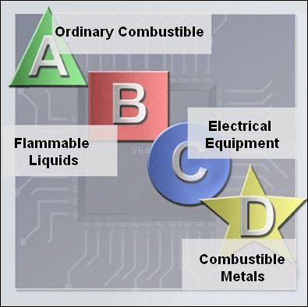

Fire extinguisher classifications might vary by country.

It is important to know how to use a fire extinguisher. Hold the canister in an upright/

vertical position and use the memory aid P-A-S-S to help you remember the basic rules

of fire extinguisher operation:

n

**P**

:

Pull the pin.

n

**A**

:

Aim at the base of the fire, not at the flames.

n

**S**

:

Squeeze the lever.

n

**S**

:

Sweep the nozzle from side to side.

**Identify Safety Procedures to Protect Equipment from**

**Damage and Data**

**from Loss**

Electrostatic discharge, harsh climates, and poor-quality sources of electricity can cause

damage to computer equipment. Follow

proper handling guidelines, be aware of environ-

mental issues, and use equipment that stabilizes power to prevent equipment damage and

data loss.

Electrostatic Discharge

Static electricity is the buildup of an electric charge resting on a surface. This buildup may

jump to a component and cause damage. This is known as

***electrostatic discharge (ESD)***

.

ESD can be destructive

to the electronics in a computer system.

At least 3000 volts of static electricity must build up before a person can feel ESD. For

example, static electricity can build up on you as you walk across a carpeted floor. When

you touch another person, you both receivea

shock. If the discharge causes pain or makes a

noise, the charge was probably above10,000 volts. By comparison, less than 30 volts of

static electricity can damage a computer component.

ESD can cause permanent damage to electrical components. Follow these recommendations

to help prevent ESD damage:

n

Keep all components in antistatic bags until you are ready to install them.

n

Use grounded mats on workbenches.

n

Use grounded floor mats in work areas.

n

Use

***antistatic wrist straps***

when working on computers.

Chapter 2: Safe Lab Procedures and Tool Use

55

Electromagnetic Interference

Electromagnetic interference (EMI)is the intrusion of outside electromagnetic signals in a

transmission media, such as copper cabling. In a network environment, EMI distorts the

signals so that the receiving devices have difficulty interpreting them.

EMI does not always come from expected sources such as cellular phones. Other types of

electric equipment can emit a silent, invisible electromagnetic field that can extend for more

than a mile.

There are many sources of EMI:

n

Any source designed to generate electromagnetic energy

n

Man-made sources, like

power lines or motors

n

Natural events, such as electrical storms or solar and other radiations from space

Wireless networks are affected by radio frequency interference (RFI). RFI is the interfer-

ence caused by radio transmitters and other devices transmitting in the same frequency.

For example, a cordless telephone can cause problems with a wireless network when both

devices use the same frequency.

Microwaves can also cause interference when positioned

in close proximity to wireless networking devices.

Climate

Climate affects computer equipment in a variety of ways:

n

If the environment temperature is too high, equipment can overheat.

n

If the humidity level is too low,

the chance of ESD increases.

n

If the humidity level is too high, equipment can suffer from moisture damage.

Table 2-1 shows how environmental conditions increase or decrease the risk of ESD.

**Table 2-1**

ESD Probability

**Conditions**

**ESD Probability**

Cool and dry

High

Warm and humid

Low

Power Fluctuation Types

Voltage

is the force that moves electrons through a circuit. The movement of electrons is

called

***current***

.Computer circuits need voltage and current to operate electronic compo-

nents. When the voltage in a computer is not accurate or steady, computer components may

not operate correctly. Unsteady voltages are called

***power fluctuations***

.

56

IT Essentials: PC Hardware and Software Companion Guide

Chapter 2: Safe Lab Procedures and Tool Use 57

The following types of AC power fluctuations can cause data loss or hardware failure:

n ***Blackout***: Complete loss of AC power. A blown fuse, damaged transformer, or downed power line can cause a blackout.

n ***Brownout***: Reduced voltage level of AC power that lasts for a period of time. Brownouts occur when the power line voltage drops below 80 percent of the normal voltage level. Overloading electrical circuits can cause a brownout.

n ***Noise***: Interference from generators and lightning. Noise results in unclean power, which can cause errors in a computer system.

n ***Spike***: Sudden increase in voltage that lasts for a very short period and exceeds 100 percent of the normal voltage on a line. Spikes can be caused by lightning strikes, but can also occur when the electrical system comes back on after a blackout.

n ***Power surge***: Dramatic increase in voltage above the normal flow of electrical current.

A power surge lasts for a few nanoseconds, or one-billionth of a second.

# Power Protection Devices

To help shield against power fluctuation issues, use ***power protection devices*** to protect the data and computer equipment:

n ***Surge suppressor***: Helps protect against damage from surges and spikes. A surge

suppressor diverts extra electrical voltage on the line to the ground.

n ***Uninterruptible power supply (UPS)***: Helps protect against potential electrical power

problems by supplying electrical power to a computer or other device. The battery is constantly recharging while the UPS is in use. The UPS is able to supply a limited amount of power when brownouts and blackouts occur. A UPS can also act as a ***line conditioner*** if it uses the battery as a buffer from the minor but erratic fluctuations found in electrical lines. This form of UPS is called inline. Many UPS devices are able to communicate directly with the operating system on a computer. This communication allows the UPS to safely shut down the computer and save data prior to the UPS losing all electrical power.

n ***Standby power supply (SPS)***: The most common type of UPS. It helps protect against potential electrical power problems by providing a backup battery to supply power when the incoming voltage drops below the normal level. The battery is on standby during the normal operation. When the voltage decreases, the battery provides DC power to a power inverter, which converts it to AC power for the computer. This device is not as reliable as a UPS because of the time it takes to switch over to the battery. If the switching device fails, the battery will not be able to supply power to the computer.

Figure 2-2 shows some examples of surge suppressors, UPSs, and SPS devices.

58

**Figure 2-2**

Surge Suppressors and UPS Devices

IT Essentials: PC Hardware and Software Companion Guide

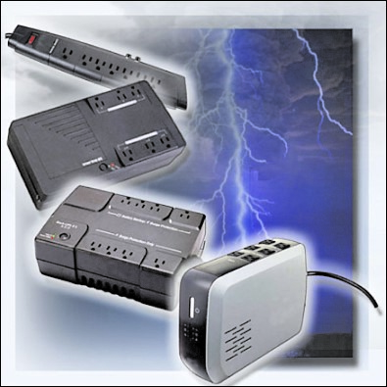

**Caution**

Never plug a printer into a UPS device. Doing so might overload the UPS device.

**Identify Safety Procedures to Protect the Environment**

**from Contamination**

Computers and peripherals contain materials that can be harmful to the environment.

Hazardous materials are sometimes called toxic waste. These materials can contain high

concentrations of heavy metals such as cadmium, lead, or mercury. The regulations for

the disposal of hazardous materials vary according to state or country. Contact the local

recycling or waste removal authorities in your community for information about disposal

procedures and services.

Material Safety Data Sheet

A

***material safety data sheet (MSDS)***

is a fact sheet that summarizes information about

material identification, including hazardous ingredients that can affect personal health, fire

hazards, and first aid requirements. In Figure 2-3, the MSDS contains chemical reactivity

and incompatibility information that includes spill, leak, and disposal procedures. It also

includes protective measures for the safe handling and storage of materials.

**Figure 2-3**

MSDS

Chapter 2: Safe Lab Procedures and Tool Use

59

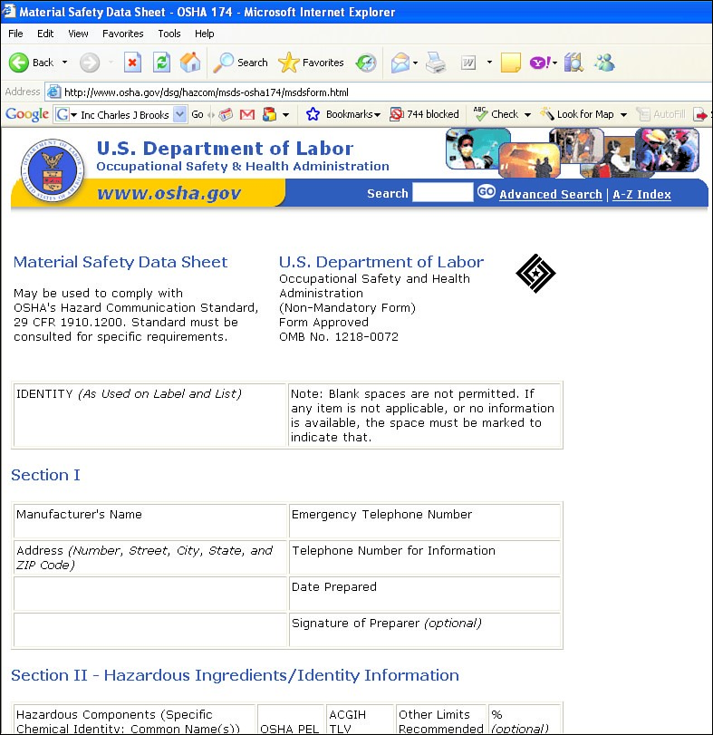

To determine whether a material is classified as hazardous, consult the manufacturer’s

MSDS. In the United States, the

***Occupational Safety Health Administration (OSHA)***

requires that all hazardous materials must be accompanied by an MSDS when transferred to

a

new owner. The MSDS information included with products purchased for computer

repairs or maintenance can be relevant to computer technicians. OSHA also requires that

employees be informed about the materials that they are working with and be provided with

material safety information. In the United Kingdom,

***Chemicals Hazard Information and***

***Packaging for Supply Regulations 2002 (CHIP 3)***

regulatethe handling of hazardous

materials. CHIP 3 requires chemical suppliers to safely package and transport dangerous

chemicals and to include a data sheet with the product.

**Note**

The MSDS is valuable in determining how to dispose of any potentially hazardous materials in the

safest manner

. Always check local regulations concerning acceptable disposal methods before dispos-

ing of any

electronic equipment.

Which organization governs the use of hazardous chemicals in your country? Are MSDSs

mandatory?

The MSDS contains valuable information:

n

The name of the material

n

The physical properties of the material

n

Any hazardous ingredients contained in the material

n

Reactivity data, such as fire and explosion data

n

Procedures for spills or leaks

n

Special precautions

n

Health hazards

n

Special protection requirements

Computers and other computing devices are eventually discarded because of one of the

following reasons:

n

Parts or components begin to fail more frequently as the device ages.

n

The computer becomes obsolete for the application for which it was originally

intended.

n

Newer models have improved features.

Before discarding a computer or any of its components, it is crucial to consider safe

disposal of each separate component.

Proper Disposal of Batteries

Batteries often contain rare earth metals that can be harmful to the environment. Batteries

from portable computer systems may contain lead, cadmium, lithium, alkaline manganese,

and mercury. These metals do not decay and will remain in the environment for many

years. Mercury is commonly used in the manufacturing of batteries and is extremely toxic

and harmful to humans.

Recycling batteries should be a standard practice for a technician. All batteries, including

lithium-ion, nickel-cadmium, nickel-metal hydride, and lead-acid, are subject to disposal

procedures that comply with local environmental regulations.

Proper Disposal of Monitors or CRTs

Handle monitorsand cathode ray tubes (CRT) with care. Extremely high voltage can be

stored in monitors and CRTs, even after being disconnected from a power source. CRTs

contain glass, metal, plastics, lead, barium, and rare earth metals. According to the U.S.

Environmental Protection Agency (EPA), CRTs may contain approximately 4 lbs (1.8 kg)

of lead. Monitors must be disposed of in compliance with environmental regulations.

60

IT Essentials: PC Hardware and Software Companion Guide

Proper Disposal of Toner Kits, Cartridges, and Developers

Used printer toner kits and printer cartridges must be disposed of properly or recycled.

Some toner cartridge suppliers and manufacturers will take empty cartridges for refilling.

There are also companies that specialize in refilling empty cartridges. Kits to refill inkjet

printer cartridges are available but are not recommended, because the ink may leak into the

printer, causing irreversible damage. This can be especially costly because using refilled

inkjet cartridges may also void the inkjet printer warranty.

Proper Disposal of Chemical Solvents and Aerosol Cans

Contact the local sanitation company to learn how and where to dispose of the chemicals

and solvents used to clean computers. Never dump chemicals or solvents down a sink or

dispose of them in any drain that connects to public sewers.

The cans or bottles that contain solvents and other cleaning supplies must be handled

carefully. Make sure that they are identified and treated as special hazardous waste. For

example, some aerosol cans may explode when exposed to heat if the contents are not

completely used.

**Identify Tools and Software Used with Personal**

**Computer Components and Their Purposes**

For every job, there is the right tool. Make sure that you are familiar with the correct use of

each tool and that you use the right tool for the current task. Skilled use of tools and soft-

ware makes the job less difficult and ensures that tasks are performed properly and safely.

Figure 2-4 shows some common tools used in computer repair.

**Figure 2-4**

Computer Tools

Chapter 2: Safe Lab Procedures and Tool Use

61

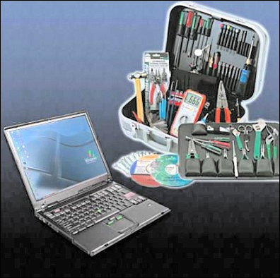

Software tools are available that help diagnose problems. Use these tools to determine

which computer device is not functioning correctly.

A

technician must document all repairs and computer problems. The documentation can

then be used as a reference for future problems or for other technicians who may not have

encountered the problem before. The documents may be paper-based, but electronic forms

are preferred because they can be easily searched for specific problems.

After completing this section, you will meet these objectives:

n

Identify hardware tools and their purpose.

n

Identify software tools and their purpose.

n

Identify organizational tools and their purpose.

**Identify**

**Hardware**

**Tools and Their Purpose**

A

toolkit should contain all of the tools necessary to complete hardware repairs. As you

gain experience, you will learn which tools to have available for different types of jobs.

Hardware tools are grouped into these four categories:

n

ESD tools

n

Hand tools

n

Cleaning tools

n

Diagnostic tools

ESD

Tools

Thereare two ESD tools: the antistatic wrist strap and the

***antistatic mat***

.

Both tools are

designed to protect the PC from ESD. The antistatic wrist strap protects computer equip-

ment when clipped to the computer chassis. The antistatic mat protects computer equipment

by preventing static electricity from accumulating on the hardware or on the technician.

Hand Tools

Most tools used in the computer assembly process are small

***hand tools***

.

They are available

individually or as part of a computer repair toolkit. Toolkits range widely in size, quality,

and price. Common hand tools include the following:

n

***Flat-head screwdriver***

:

Used to tighten or loosen slotted screws

n

***Phillips-head screwdriver***

:

Used to tighten or loosen cross-headed screws

n

**Torx screwdriver**

:

Used to tighten or loosen screws that have a star-like depression on

the top, a feature that is mainly found on laptops

IT Essentials: PC Hardware and Software Companion Guide

62

n

***Hex driver***

:

Used to tighten or loosen nuts in the same way that a screwdriver tightens

or loosens screws (sometimes called a

*nut driver*

)

n

***Needle-nose pliers***

:

Used to hold small parts

n

**Wire cutters**

:

Used to strip and cut wires

n

***Tweezers***

:

Used to manipulate small parts

n

***Part retriever***

:

Used to retrieve parts from locations that are too small for your hand

to fit

n

**Flashlight**

:

Used to light up areas that you cannot see well

Cleaning Tools

Havingthe appropriate

***cleaning tools***

is essential when maintaining or repairing computers.

Using these tools ensures that computer components are not damaged during cleaning.

Cleaning tools include the following:

n

**Soft cloth**

:

Used to clean different computer components without scratching or leaving

debris

n

**Compressed air**

:

Used to blow away dust and debris from different computer parts

without touching the components

n

**Cable ties**

:

Used to bundle cables neatly inside and outside of a computer

n

**Parts organizer**

:

Used to hold screws, jumpers, fasteners, and other small parts and

prevent them from getting mixed together

Diagnostic Tools

***Diagnostic tools***

includethe following:

n

**Digital multimeter**

:

Used to test the integrity of circuits and the quality of electricity

in computer components

n

**Loopback adapter**

:

Used to test the basic functionality of computer ports

**Identify Software Tools and Their Purpose**

A

technician must be able to use a range of software tools to help diagnose problems, main-

tain hardware, and protect the data stored on a computer.

Disk Management Tools

***Disk management tools***

help detect and correct disk errors, prepare a disk for data storage,

and remove unwanted files. The following are disk management tools:

Chapter 2: Safe Lab Procedures and Tool Use

63

n

***Format***

:

Prepares a hard drive to store information

n

***Scandisk***

**or Chkdsk**

:

Checks the integrity of files and folders on a hard drive by

scanning the file system; may also check the disk surface for physical errors

n

***Defrag***

:

Optimizes space on a hard drive to allow faster access to programs and data

n

***Disk Cleanup***

:

Clears space on a hard drive by searching for files that can be safely

deleted

n

***Disk Management***

:

Initializes disks, and creates, deletes, and formats partitions

n

**System File Checker (SFC)**

:

Scans the operating system critical files and replaces any

files that are corrupted

Use the Windows boot disk for troubleshooting and repairing corrupted files. The Windows

boot disk is designed to repair Windows system files, restore damaged or lost files, and

reinstall the operating system. Be sure to use the same OS boot disk as the OS installed on

the PC. Use a Windows XP CD to troubleshoot a Windows XP PC, a Windows Vista CD or

DVD on a Windows Vista PC, and so on. Third-party software tools are available to assist

in troubleshooting problems.

Protection Software Tools

Each year,

viruses, spyware, and other types of malicious attacks infect millions of

computers. These attacks can damage an operating system, application, and data.

Computers that have been infected may even have problems with hardware performance

or component failure.

To

protect data and the integrity of the operating system and hardware, use software

designed to guard against attacks and to remove

malicious programs.

Various types of software are used to protect hardware and data:

n

**Windows XP Security Center**

:

Checks the status of essential security settings. The

Security Center continuously checks to make sure that the software firewall and

antivirus programs are running. It also ensures that automatic updates are set to down-

load and install automatically.

n

**Antivirus program**

:

Protects against virus attacks.

n

**Spyware remover**

:

Protects against software that sends information about web surfing

habits to an attacker.Spyware can be installed without the knowledge or consent of the

user.

n

**Firewall program**

:

Runs continuously to protect against unauthorized communications

to and from your computer.

IT Essentials: PC Hardware and Software Companion Guide

64

**Worksheet 2.2.2: Diagnostic Software**

In this worksheet, you will use the Internet, a newspaper, or a local store to gather informa-

tion about a hard drive diagnostic program. Be prepared to discuss the diagnostic software

you researched. Refer to the worksheet in

*IT Essentials: PC Hardware and Software Lab*

*Manual, Fourth Edition*

.

You can complete this worksheet now or wait to do so until the

end of the chapter.

**Identify Organizational Tools and Their Purpose**

It is important that a technician document all services and repairs. These documents need to

be stored centrally and made available to all other technicians. The documentation can then

be used as reference material for similar problems that are encountered in the future. Good

customer service includes providing the customer with a detailed description of the problem

and the solution.

Personal Reference Tools

Personal

reference tools include the following:

n

**Notes**

:

Make notes as you go through the investigation and repair process. Refer to

these notes to avoid repeating previous steps and to determine what steps to take next.

n

**Journal**

:

Document the upgrades and repairs that you perform. The documentation

should include descriptions of the problem, possible solutions that have been tried to

correct the problem, and the steps taken to repair the problem. Be sure to note any con-

figuration changes made to the equipment and any

replacement parts used in the repair.

Your journal, along with your notes, can be valuable when you encounter similar situa-

tions in the future.

n

**History of repairs**

:

Make a detailed list of problems and repairs, including the date,

replacement parts, and customer information. The history allows a technician to deter-

mine what work has been performed on a computer in the past.

**Note**

Keeping an electronic journal stored on a computer can be helpful for later troubleshooting because

you can more easily search for possible solutions in electronic documents than in paper documents.

Internet Reference Tools

The Internet is an excellent source of information about specific hardware problems and

possible solutions. You find this information through the following resources:

n

Internet search engines

n

Newsgroups

Chapter 2: Safe Lab Procedures and Tool Use

65

n

Manufacturer FAQs

n

Online computer manuals

n

Online forums and chat

n

Technical websites

Miscellaneous Tools

With experience, you will discover many additional items to add to the toolkit. Figure 2-5

shows case and drive mounting screws.

**Figure 2-5**

Labeled Computer Parts

66

IT Essentials: PC Hardware and Software Companion Guide

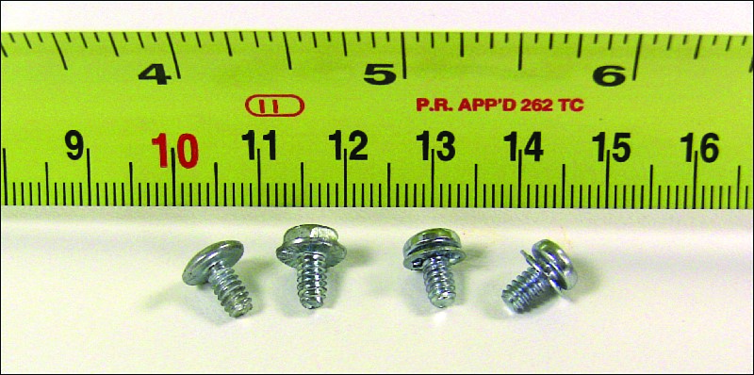

Case Screws

Drive Mounting Screws

A

laptopis also a valuable resource to take with you on computer repairs in the field.

Having your own working computer on a site visit can be used to research information,

download tools or drivers, or communicate with other technicians.

Your toolkit should also include a variety of replacement parts. Figure 2-6 shows the types

of replacement computer parts you might want to keep handy. Make sure that the parts are

in good working order before you use them. Using known good components to replace

possible bad ones in computers will help you quickly determine which component may

not be working properly. You should store sensitive components, such as RAM, cards, and

CPUs, in an antistatic bag prior to installation, as shown in Figure 2-7.

**Figure 2-6**

Replacement Computer Parts

Chapter 2: Safe Lab Procedures and Tool Use

67

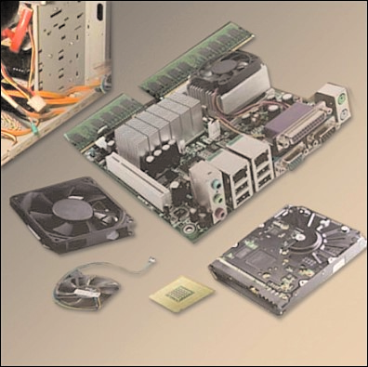

**Figure 2-7**

Store Replacement Computer Parts in an Antistatic Bag

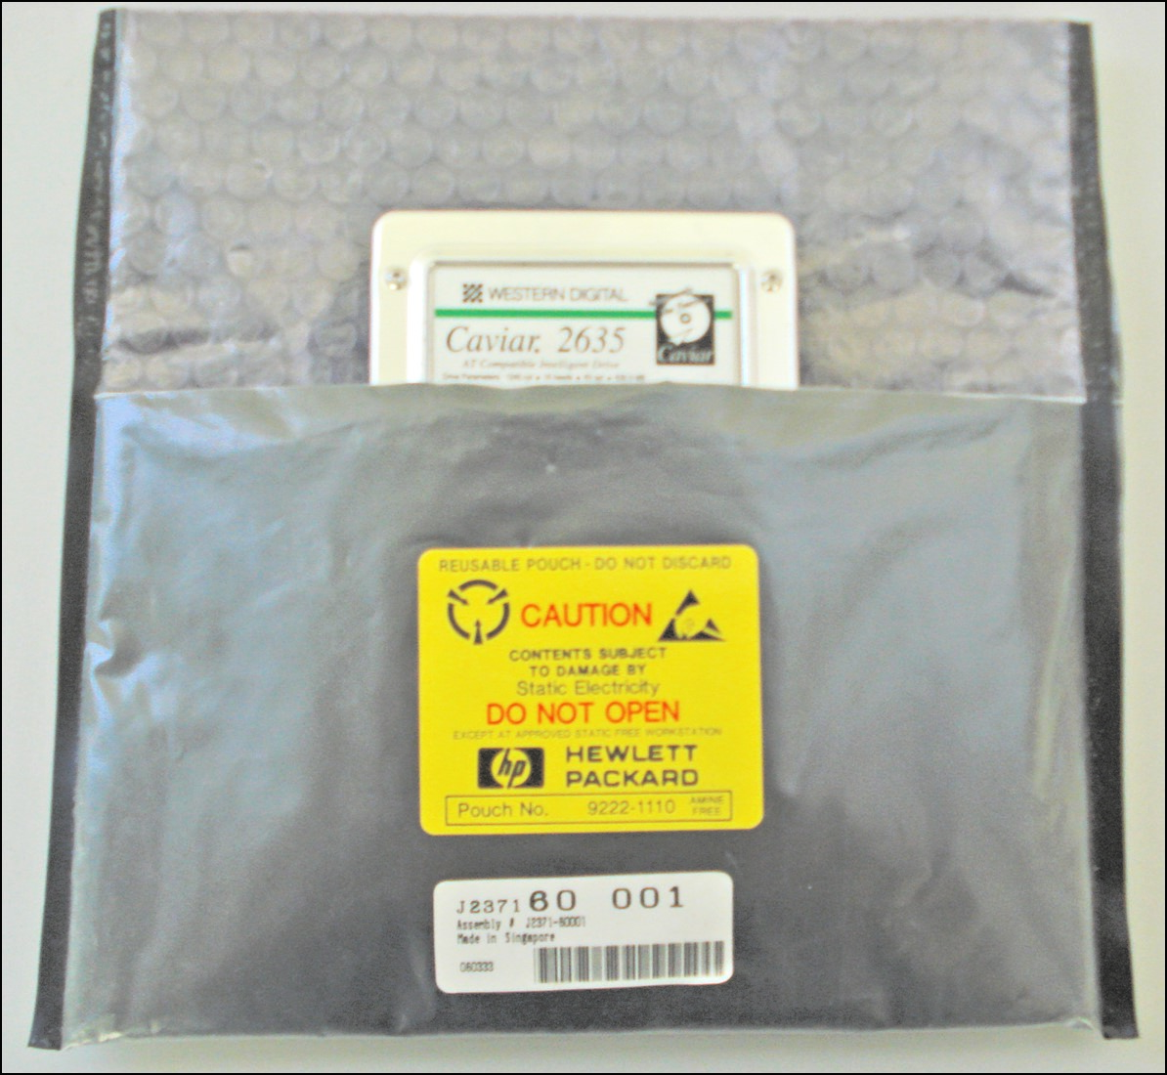

**Lab 2.3.4: Computer Disassembly**

In this lab, you will disassemble a computer using safe lab procedures and the proper tools.

Use extreme care and follow all safety procedures. Familiarize yourself with the tools you

will be using in this lab. Refer to the lab in

*IT Essentials: PC Hardware and Software Lab*

*Manual, Fourth Edition*

.

You can perform this lab now or wait until the end of the chapter.

**Implement Proper Tool Use**

Safety in the workplace is everyone’s responsibility. You are much less likely to injure

yourself or damage components when using the proper tool for the job.

Before cleaning or repairing equipment, check to make sure that your tools are in good con-

dition. Clean, repair,

or replace any

items that are not functioning adequately.

After completing this section, you will meet these objectives:

n

Demonstrate proper use of an antistatic wrist strap.

n

Demonstrate proper use of an antistatic mat.

n

Demonstrate proper use of various hand tools.

n

Demonstrate proper use of cleaning materials.

**Demonstrate Proper Use of an Antistatic Wrist Strap**

As discussed previously,

an example of ESD is the small shock that you receive

when

you walk across a room with carpet and touch a doorknob. Although the small shock is

harmless to you, the same electrical charge passing from you to a computer can damage

its components. Wearing an antistatic wrist strap can prevent ESD damage to computer

components.

The purpose of an antistatic wrist strap is to equalize the electrical charge between you and

the equipment. The antistatic wrist strap is a conductor that connects your body to the

equipment that you are working on. When static electricity builds up in your body, the con-

nection made by the wrist strap to the equipment, or ground, channels the electricity

through the wire that connects the strap.

As shown in Figure 2-8, an antistatic wrist strap has two parts and is easy to wear.

Following is the proper procedure for using an antistatic wrist strap:

**Step 1.**

Wrap the strap around your wrist and secure it using the snap or Velcro. The

metal on the back of the wrist strap must remain in contact with your skin at

all times.

IT Essentials: PC Hardware and Software Companion Guide

68

**How To**

**Step 2.**

Snap the connector on the end of the wire to the wrist strap, and connect the

other end either to the equipment or to the same grounding point that the antista-

tic mat is connected to. The metal skeleton of the case is a good place to connect

the wire. When connecting the wire to equipment that you are working on,

choose an unpainted metal surface. A painted surface does not conduct the elec-

tricity as well as unpainted metal.

**Figure 2-8**

Antistatic Wrist Strap

Chapter 2: Safe Lab Procedures and Tool Use

69

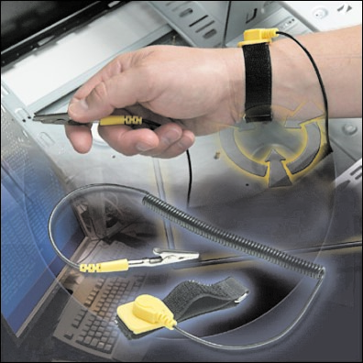

**Note**

Attach the wire on the same side of the equipment as the arm wearing the antistatic wrist strap. This

will help to keep the wire out of the way while you are working.

Although wearing a wrist strap will help to prevent ESD, you can further reduce the risks

by not wearing clothing made of silk, polyester,

or wool. These fabrics are more likely to

generate a static charge.

**Note**

Technicians should roll up their sleeves, remo

ve scarves or ties, and tuck in their shirts to prevent

interference from clothing. Ensure that earrings, necklaces, and other loose jewelry are properly

secured or removed.

**Caution**

Never wear an antistatic wrist strap if you are repairing a monitor or a power supply unit.

**Demonstrate Proper Use of an Antistatic Mat**

Youmay not always have the option to work on a computer in a properly equipped

workspace that includes workbenches and antistatic mats. If you can control the environ-

ment, try to set up your workspace away from carpeted areas. Carpets can cause the

buildup of electrostatic charges. If you cannot avoid the carpeting, ground yourself to

the unpainted portion of the case of the computer on which you are working before

touching any components.

Antistatic Mat

An antistatic mat is slightly conductive. It works by drawing static electricity away from

a

component and transferring it safely from equipment to a grounding point, as shown in

Figure 2-9. Following is the proper procedure for using an antistatic mat:

**Step 1.**

Lay the mat on the workspace next to or under the computer case.

**Step 2.**

Clip the mat to the case to provide a grounded surface on which you can

place parts as you remove them from the system. Additional connections

to the electrical earth ground is a best practice.

**Figure 2-9**

Antistatic Mat

70

IT Essentials: PC Hardware and Software Companion Guide

**How To**

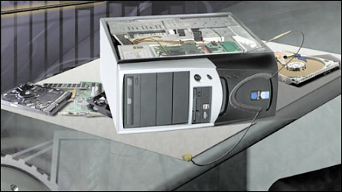

Reducing the potential for ESD reduces the likelihood of damage to delicate circuits or

components.

**Note**

Always handle components by the edges.

Workbench

When you are working at a

***workbench***

,

ground the workbench and the antistatic floor mat.

By standing on the floor mat and wearing the wrist strap, your body has the same charge as

the equipment and reduces the probability of ESD. Either connect the table-top mat and the

floor mat to each other or connect both to the electrical earth ground.

**Demonstrate Proper Use of Various Hand Tools**

A

technician needs to be able to properly use each tool in the toolkit. This topic covers

many of the various hand tools used when repairing computers.

Screws

Matcheach screw with the proper screwdriver. Place the tip of the screwdriver on the head

of the screw. Turn the screwdriver clockwise to tighten the screw and counterclockwise to

loosen the screw.

Screws can become stripped if you over-tighten them with a screwdriver. A stripped screw,

shown in Figure 2-10, may get stuck in the screw hole or may not tighten firmly. Discard

stripped screws.

**Figure 2-10**

Stripped Screw

Chapter 2: Safe Lab Procedures and Tool Use

71

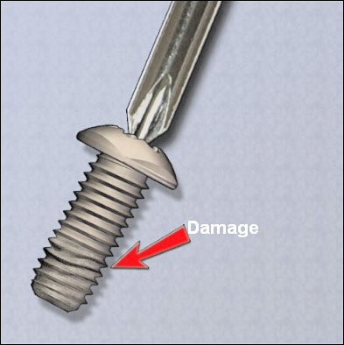

Flat-Head Screwdriver

Use a flat-head screwdriverwhen you are working with a slotted screw. Do not use a flat-

head screwdriver to removea

Phillips-head screw.

Neveruse a screwdriver as a pry bar.

**Caution**

If excessive

force is needed to remo

ve or add a component, something is probably wrong. Take a sec-

ond look to make sure that you have not missed a screw or a locking clip that is holding the compo-

nent in place. Refer to the device manual or diagram for additional information.

72 IT Essentials: PC Hardware and Software Companion Guide

|  |  |  |
| --- | --- | --- |
| Hex Driver  (  **Figure 2-11** | | Phillips-Head Screwdriver  Use a Phillips-head screwdriver with crosshead screws. Do not use this type of screwdriver  to puncture anything. This will damage the head of the screwdriver.  Use ahex driver, shown in Figure 2-11, to loosen and tighten bolts that have a hexagonal  six-sided) head. Hex bolts should not be over-tightened because the threads of the bolts can  be stripped. Do not use a hex driver that is too large for the bolt that you are using.  Hex Driver |
|  | **Caution** |  |

Some tools are magnetized. When working around electronic devices, be sure that the tools you are using have not been magnetized. Magnetic fields can be harmful to data stored on magnetic media. Test your tool by touching the tool with a metal screw. If the screw is attracted to the tool, do not use the tool.

# Part Retriever, Needle-Nose Pliers, or Tweezers

The part retriever, needle-nose pliers, and tweezers, shown in Figure 2-12, can be used to place and retrieve parts that may be hard to reach with your fingers. Do not scratch or hit any components when using these tools.

**Figure 2-12**

Component-Retrieving Tools

Chapter 2: Safe Lab Procedures and Tool Use

73

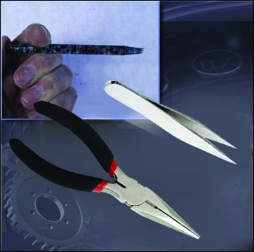

Part retriever

Tweezers

Needle-nose pliers

**Caution**

Do not use a pencil inside the computer to change the setting of switches or to pry off

jumpers. The

pencil lead can act as a conductor and may damage the computer components.

**Demonstrate Proper Use of Cleaning Materials**

Keeping computers clean inside and out is a vital part of a maintenance program. Dirt

can cause problems with the physical operation of fans, buttons, and other mechanical

components. Severe dust can build up on computer components. On electrical components,

an excessive

buildup of dust will act like an insulator and trap the heat. This insulation

will impair the ability of heat sinks and cooling fans to keep components cool, causing

chips and circuits to overheat and fail.

**Caution**

When you use compressed air to clean inside the computer, blow air around the components with a

minimum distance of four inches from the nozzle. Clean the po

wer supply and the fan from the back

of the case. Do not shake compressed air. The can must be held upright when in use.

**Caution**

Before cleaning any

device, turn it off

and unplug the device from the power source.

Computer Cases and Monitors

Clean computer cases and the outside of monitors with a mild cleaning solution on a damp,

lint-free cloth. Mix one drop of dishwashing liquid with four ounces of water to create the

cleaning solution. If any water drips inside the case, allow enough time for the liquid to dry

before powering on the computer.

LCD Screens

Do not use ammoniated glass cleaners or any other solution on a liquid crystal display

(

LCD) screen, unless the cleaner is specifically designed for the purpose. Harsh chemicals

will damage the coating on the screen. There is no glass protecting these screens, so be

gentle when cleaning them and do not press firmly on the screen.

CRT Screens

To clean the screens of CRT monitors, dampen a soft, clean, lint-free cloth with distilled

water and wipe the screen from top to bottom. Then use a soft, dry cloth to wipe the screen

and remove any streaking after you have cleaned the monitor.

Clean dusty components with a can ofcompressed air.

Compressed air does not cause elec-

trostatic buildup on components. Make

sure that you are in a well-ventilated area before

blowing the dust out of the computer. A best practice is to wear a dust mask to make sure

that you do not breathe in the dust particles.

Blow

out the dust using short bursts from the can. Never tip the can or use the compressed

air can upside down. Do not allow

the fan blades to spin from the force of the compressed

air. Hold the fan in place. Fan motors can be ruined from spinning when the motor is not

turned on.

Component Contacts

Cleanthe contacts on components with isopropyl alcohol. Do not use rubbing alcohol.

Rubbing alcohol contains impurities that can damage contacts. Make sure that the contacts

do not collect any

lint from the cloth or cotton swab.

Blow any lint off the contacts with

compressed air before reinstallation.

Keyboard

Clean a desktop keyboard with compressed air or a small, hand-held vacuum cleaner with a

brush attachment.

**Caution**

Never use a standard vacuum cleaner inside a computer case. The plastic parts of the vacuum cleaner

can b

uild up static electricity and discharge to the components. Use only a vacuum approved for elec-

tronic components.

74

IT Essentials: PC Hardware and Software Companion Guide

Mouse

Useglass cleaner and a soft cloth to clean the outside of the mouse. Do not spray glass

cleaner directly on the mouse. If cleaning a ball mouse, you can remove the ball and clean

it with glass cleaner and a soft cloth. Wipe the rollers clean inside the mouse with the same

cloth. Do not spray any liquids inside the mouse.

The following list documents the computer items that you should clean and the cleaning

materials you should use in each case:

n

**Computer case and outside of monitor**

:

Mild cleaning solution of dishwashing liquid

and water

n

**LCD screen**

:

Mild cleaning solution of dishwashing liquid and water

n

**CRT screen**

:

Glass cleaner and soft cloth (spray on the cloth, not on the screen)

n

**Heat sink**

:

Compressed air

n

**RAM stick**

:

Isopropyl alcohol and some Q-tips

n

**Keyboard**

:

Handheld vacuum cleaner with a brush attachment

n

**Mouse**

:

Glass cleaner and soft cloth (spray on the cloth, not on the mouse)

75

Chapter 2: Safe Lab Procedures and Tool Use

IT Essentials: PC Hardware and Software Companion Guide

76

**Summary**

This chapter discussed safe lab procedures, correct tool usage, and the proper disposal of

computer components and supplies. You have familiarized yourself in the lab with many of

the tools used to build, service, and clean computer and electronic components. You have

also learned the importance of organizational tools and found out how these tools help you

work more efficiently.

The following are some of the important concepts to remember from this chapter:

n

Work in a safe manner to protect both users and equipment.

n

Follow all safety guidelines to prevent injuries to yourself and to others.

n

Know how to protect equipment from ESD damage.

n

Know about and be able to prevent power issues that can cause equipment damage or

data loss.

n

Know which products and supplies require special disposal procedures.

n

Familiarize yourself with MSDSs for both safety issues and disposal restrictions to help

protect the environment.

n

Use the correct tool for the task.

n

Know how to clean components safely.

n

Use organizational tools during computer repairs.

**Summary of Exercises**

This is a summary of the Labs, Worksheets, Remote Technician exercises, Class

Discussions, Virtual Desktop activities, and Virtual Laptop activities associated with this

chapter.

**Labs**

The following lab covers material from this chapter. Refer to the lab in

*IT Essentials: PC*

*Hardware*

*and Software*

*Lab Manual, Fourth Edition*

.

**Lab 2.3.4: Computer Disassembly**

**Worksheets**

The following worksheet covers material from this chapter. Refer to the worksheet in

*IT*

*Essentials: PC Hardware and Software Lab Manual, Fourth Edition*

.

**Worksheet 2.2.2: Diagnostic Softwar**

**e**

Chapter 2: Safe Lab Procedures and Tool Use

77

**Check Your Understanding**

You can find the answers to these questions in the appendix, “Answers to Check Your

Understanding Questions.”

**1.**

What class of fire extinguisher is used to extinguish electrical equipment fires?

A.Class A

B.Class B

C.Class C

D.Class D

**2.**

Which of the following is a fact sheet that summarizes information about material iden-

tification, including hazardous ingredients that can affect personal health, fire hazards,

and first aid requirements?

A.ESD

B.MSDS

C.OSHA

D.UPS

**3.**

Which of the following can cause permanent damage to electrical components if you

do not use proper tools and safety procedures?

A.ESD

B.UPS

C.MSDS

D.OSHA

**4.**

What is the minimum level of electrostatic discharge that a person can normally feel?

A.5volts

B.1000 volts

C.3000 volts

D.10,000 volts

**5.**

Which recommendation should be followed first when a fire in the workplace is out of

control?

A.Try to use the elevators to get to the lowest floor faster.

B.

Get out of the room or building and contact emergency

services for help.

C.Use the company water system to stop the fire from extending to other areas.

D.Try to control the fire with proper extinguishers.

78

IT Essentials: PC Hardware and Software Companion Guide

**6.**

Which of the following tools are recommended for cleaning a PC? (Choose two.)

A.Antibacterial spray

B.Compressed air

C.Mild abrasive detergent

D.Nylon brush

E.Rubbing alcohol

F.Soft cloth

**7.**

How does a technician discharge static buildup?

A.Touching the painted part of the computer case

B.Touching an unpainted part of the computer case

C.Touching an antistatic wrist strap before touching any computer equipment

D.Touching an antistatic mat before touching any computer equipment

**8.**

Which device is designed specifically to protect computers and electrical devices from

excess electrical voltage?

A.Power strip

B.Standby power supply

C.

Surge protector

D.Uninterruptible power supply

**9.**

Which of the following effects can be observed on computer components as a result of

climate? (Choose three.)

A.

Components overheat if the climate is too hot.

B.

Moisture damages computer parts if the climate is too humid.

C.Components work too slowly if the climate is too cold.

D.The risk of ESD increases if the humidity is too low.

E.The risk of ESD increases if the temperature is too high.

F.Components overheat if the humidity is too low.

**10.**

Which condition refers to a sudden and dramatic increase in voltage, which is usually

caused by lighting?

A.Brownout

B.Sag

C.Spike

D.Surge